CGT 270 Data Visualization Fall 2021

Module II

Week 5

**Lab 5: Critique & Refine**

**Megan Jacobs**

The goal of this lab is to critique and refine visualizations you created in Lab 4: Filter & Represent using your **Tableau Training Data**. In this lab you will perform a self-critique of the two visualizations you created last week and refine each of the visualizations.

**Part I**

Load each visualization to the website below, then perform your self-critique/assessment

<https://stephanieevergreen.com/rate-your-visualization/>

For each visualization you will rate all 24 checkpoints in about 5 minutes or less (per visualization). At the end, you’ll see your visual’s total score, along with a list of the checkpoints where you rocked it and places where you could improve. **Save your scores for each visualization (Print to PDF) and upload it with your assignment.**

By the end of Part I you should be able to

|  |  |
| --- | --- |
| Remember | *Recall* [visualization principles](https://data.ucop.edu/support-training/tableau-files/goodenoughtogreat.pdf). |
| Understand | *Discuss* [data visualization best practices.](https://www.dataplusscience.com/files/visual-analysis-guidebook.pdf) |
| Apply | *Examine* visualization solution(s) for insight. |
| Evaluate | *Assess* data visualization products for impact & effectiveness of visualization(s). |
| Analysis | *Distinguish*between the question being asked and the visual solution provided; does the visualization address/answer the question(s) . |
| Create | *Propose* and make recommendations for improvement. |

**Part II**

You will need the Andy Kirk Book.

By the end of Part II, you should be able to:

|  |  |
| --- | --- |
| Remember | *Describe* what happens in the **refine** stage. |
| Understand | **Describe** what stages are impacted by the **refine** stage and how. |
| Apply | **Implement** some method(s) or technique(s) to make the visualization better. |
| Evaluate | **Evaluate** the advantages and disadvantages of the changes made. |
| Analysis | **Explain** the rationale for the features that were refined. |
| Create | **Generate, produce and/or**improve the visualization. [Tips to improve your data visualization design.](https://www.columnfivemedia.com/25-tips-to-upgrade-your-data-visualization-design/) | |

The Andy Kirk Book (Data Visualization Handbook for Data Driven Design) contains a gallery of visualization chart types (CHRTS) located in Chapter 6: Data Representation). Each chart type in the gallery includes: representation description, an example, how to read it and what to look for, presentation tips and variations and alternative chart types.

Locate the chart type you chose to represent your data as part of the Filter & Represent Lab (Week 4) in in the gallery of visualization chart types. For each of the visualizations you created in the Filter & Represent Lab (Week 4) locate the variations and alternatives section on the gallery page and choose one of the variations and/or alternative chart type to represent the refined version of your visualization.

For example, if you created a bar chart, find out what variations and alternative chart types are recommended. Using the same data, you used in the Filter and Represent lab, create a new visualization using one of the variation or alternative chart types.

You must use data visualization best practices (see **Data Visualization Check list**).

Perform a self-assessment of the newly created visualizations (see Part I).

**WHAT TO TURN IN**

Part I: Critique

1. Self-assessment of the two visualizations you created in the Filter & Represent Lab (Week 4); saved in PDF format
   1. LastnameFirstInitial_Fig1SelfAssessmentScore.pdf
   2. LastnameFirstInitial_Fig2SelfAssessmentScore.pdf

Part II: Refine

Make sure you use data visualization best practices (See Data Visualization Check list).

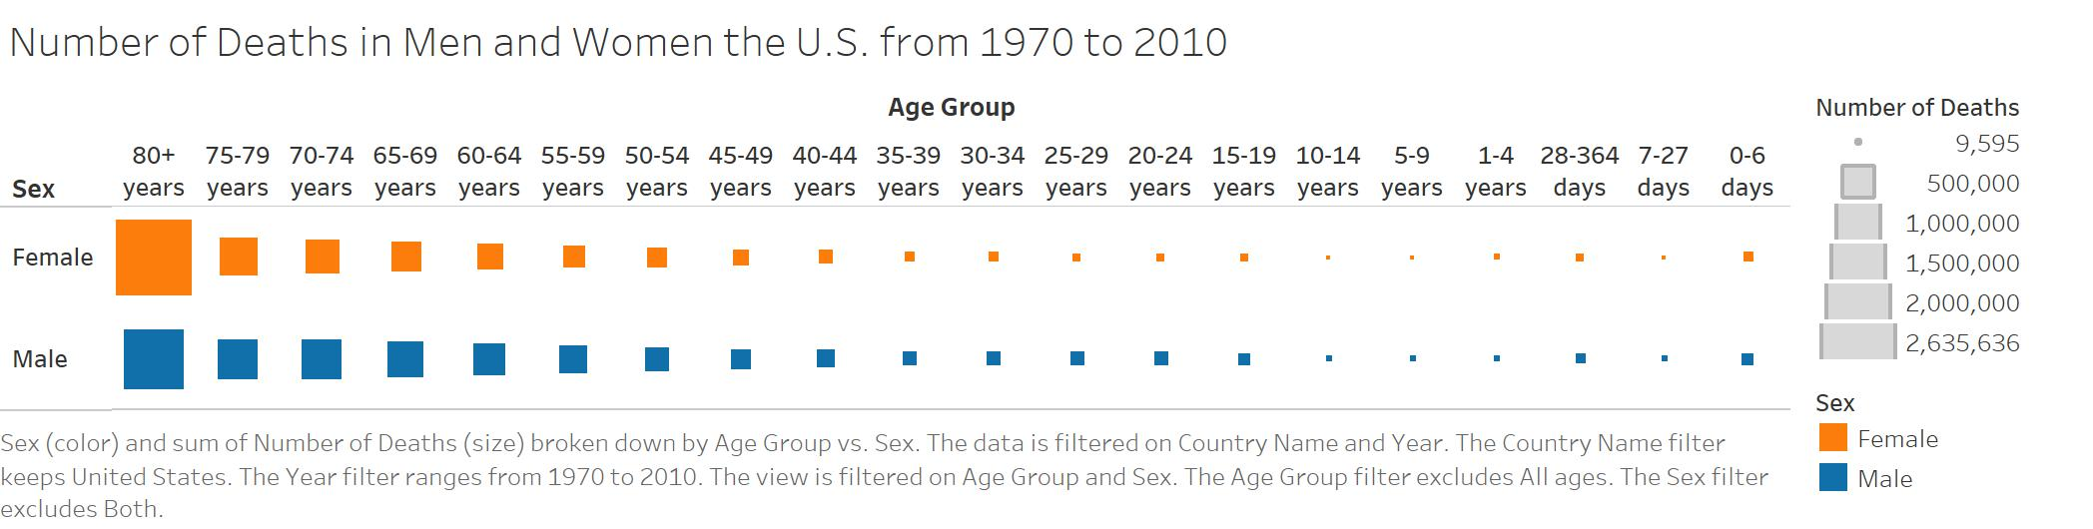

**Figure 1**

Original Chart type: Highlight Chart

Refined Chart type: Matrix Chart/Heat Chart

How to read it and what to look for: I changed my highlight chart into a heat chart because I really wanted to pronounce the difference between the number of deaths between males and females across their age groups. There is an interesting pattern that was somewhat highlighted in the highlight chart but it is emphasized more within the Heat/Matrix chart. The reason why I also changed it was because of this quote within Andy Kirk’s book “An alternative chart approach would be the ‘matrix chart’ using the size of a shape or the frequency of clustered point marks to indicate a quantitative value”. The sizing of the square is what I focused on so that we can see the distinct difference between males and females. Anyways the way that you are suppose to read this chart is that sex is on the left side and age group is located across the x-axis. You can see the comparison across the age groups and compare the differences between the two.

Figure Caption: Fig 1 is a comparison between number of deaths between Males and Females within the United States from 1970 to 2010 according to their age groupings.

Export the refined visualization as an image, save as LastnameFirstInitial_Fig1Refined.jpg

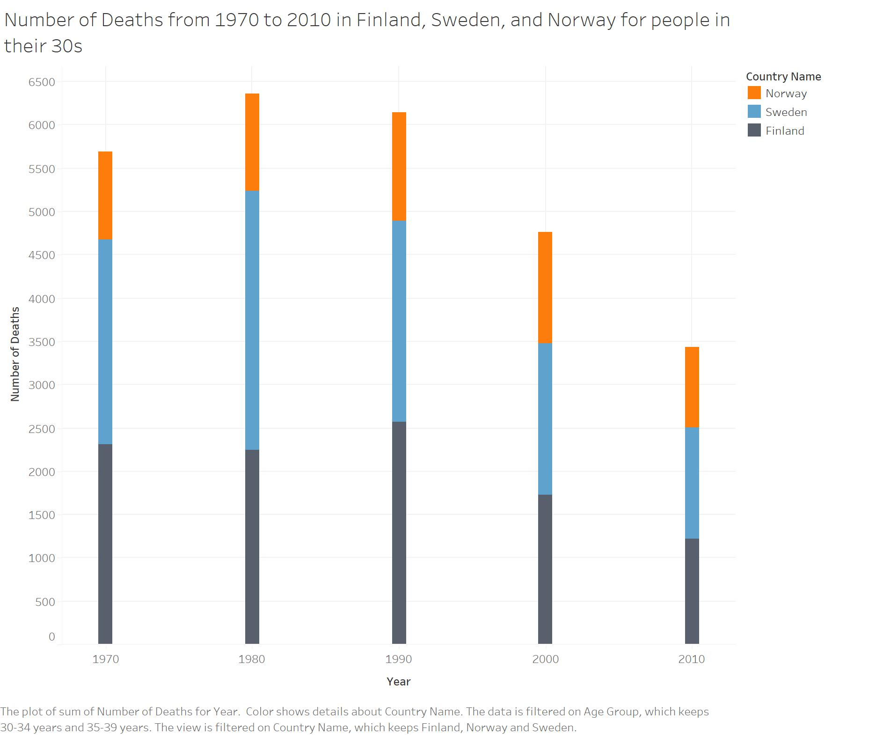

**Figure 2**

Original Chart type: LineChart

Refined Chart type: Bar Chart

How to read it and what to look for: I changed my diagram from a line chart to a bar chart since according to Andy Kirk’s book “An alternative would to use the ‘bar chart’ when you have quantities for discrete periods (such as totals over a monthly period) rather than a purely continuous series of point-in-time measurements.” Within my chart I am using a discrete period of time which is from 1970 to 2010 and comparing every 10 years to each other. The different colors represent the different countries, the y axis is the number of deaths for each country and finally the x axis is the year in which we are comparing.

Figure Caption: Fig. 2 is a bar chart comparing number of deaths in Finland, Norway, and Sweden for people between the ages of 30 to 39 years old.

Export the refined visualization as an image, save as LastnameFirstInitial_Fig2Refined.jpg

**(PNG files WILL NOT be graded)**